NAME :DODIYA NIYA YASHVANTBHAI

ROLL NO:2199

SUB:JAVA PRECTICAL

DIV:FA2

First program name and roll no

public class first{

    public static void main(String[] args){

        System.out.println("NAME:-- DODIYA NIYA YASHVANTBHAI");

        System.out.println("DIVISION:-- FA2");

        System.out.println("ROLL NO:-- 2199");

        System.out.println("SUBJECT:-- JAVA PRECTICAL");

    }

}

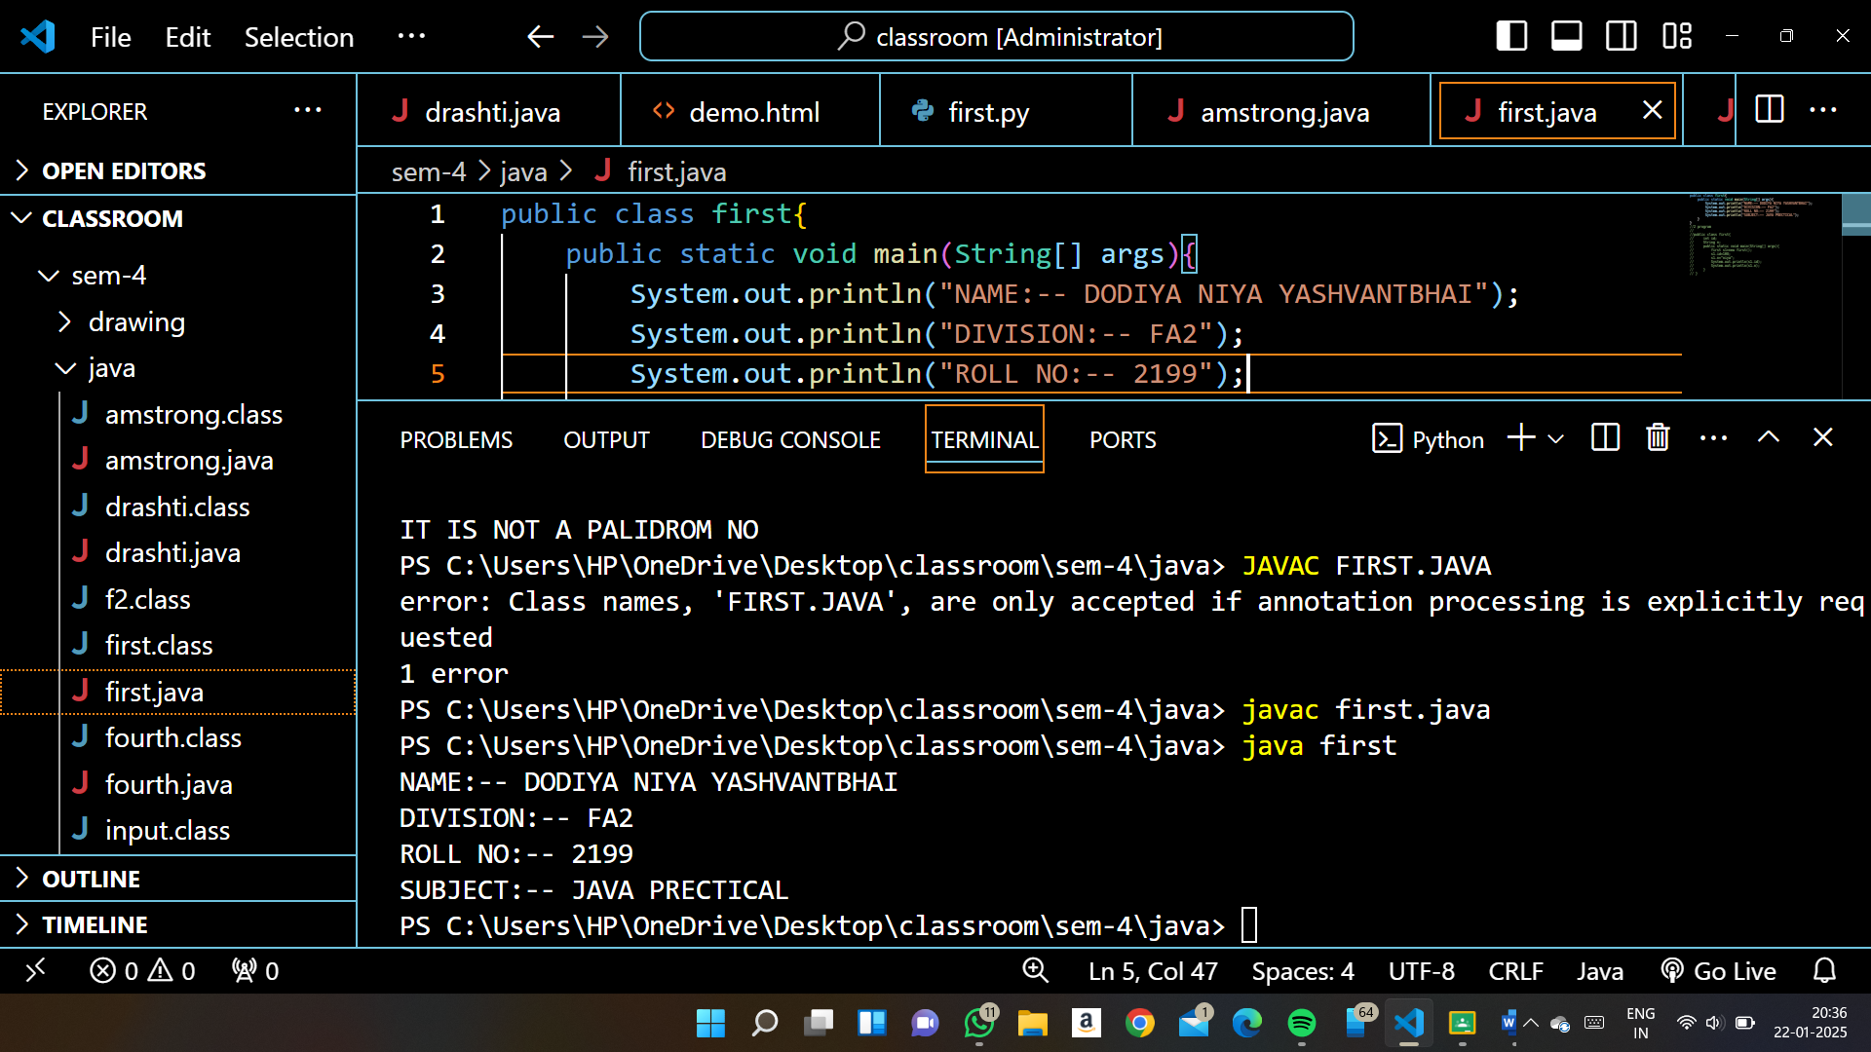

1)check no is negative,positive or zero

public class first{

    public static void main(String[] args){

      Scanner sc=new Scanner(System.in);

      System.out.println("enter the no");

      int n=sc.nextInt();

      if(n>0){

        System.out.println("NO IS POSITIVE");

      }

      else if(n<0){

        System.out.println("NO IS NEGATIVE");

      }

      else if(n==0){

        System.out.println("NO IS ZERO");

      }

      }

    }

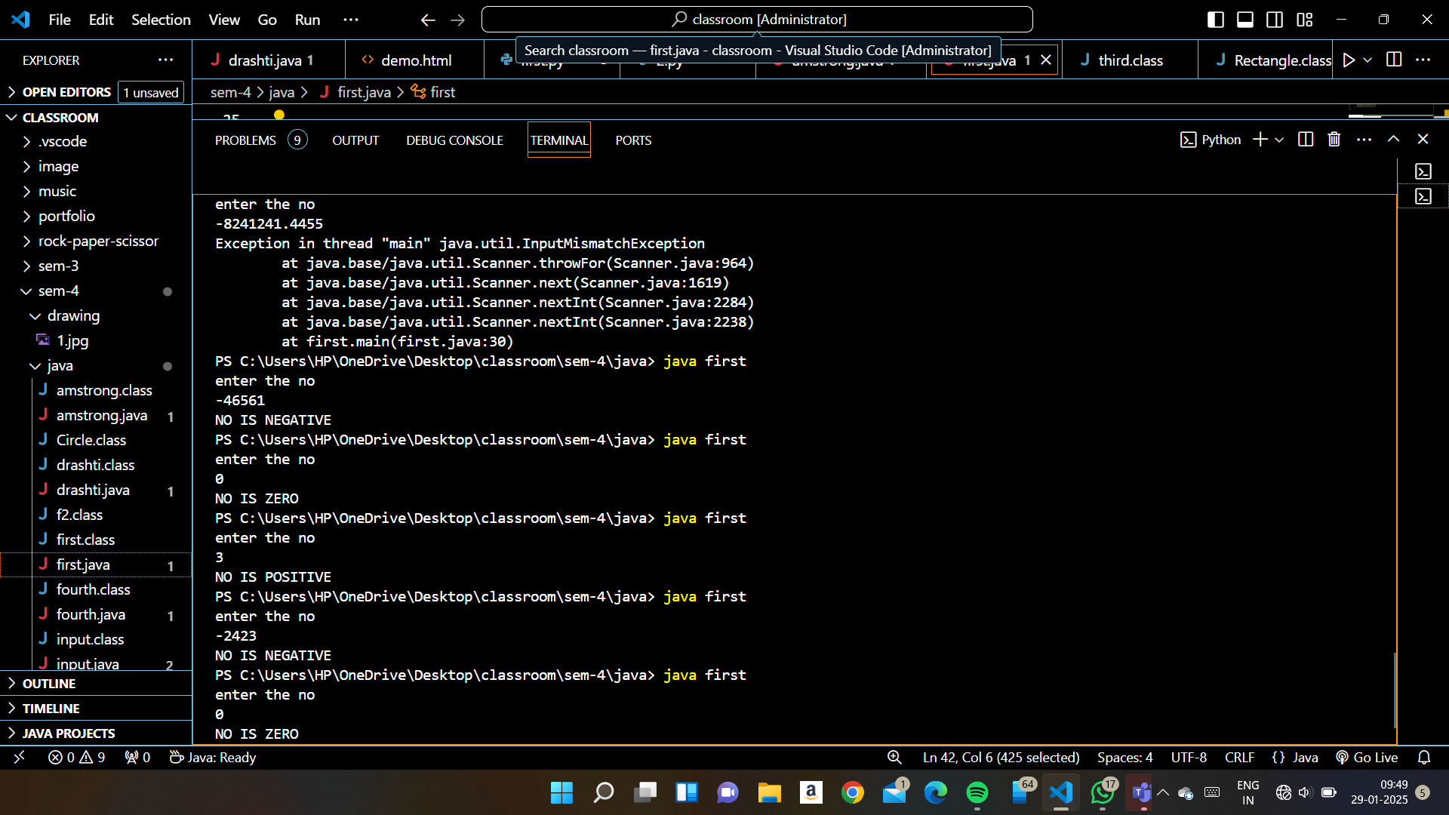

2) writte a program to find no is even or odd take value from user

public class first{

    public static void main(String[] args){

      Scanner sc=new Scanner(System.in);

      System.out.println("enter the no");

      int n=sc.nextInt();

      if(n%2==0){

        System.out.println("NO IS EVEN");

      }

      else{

        System.out.println("NO IS ODD");

      }

      }

    }

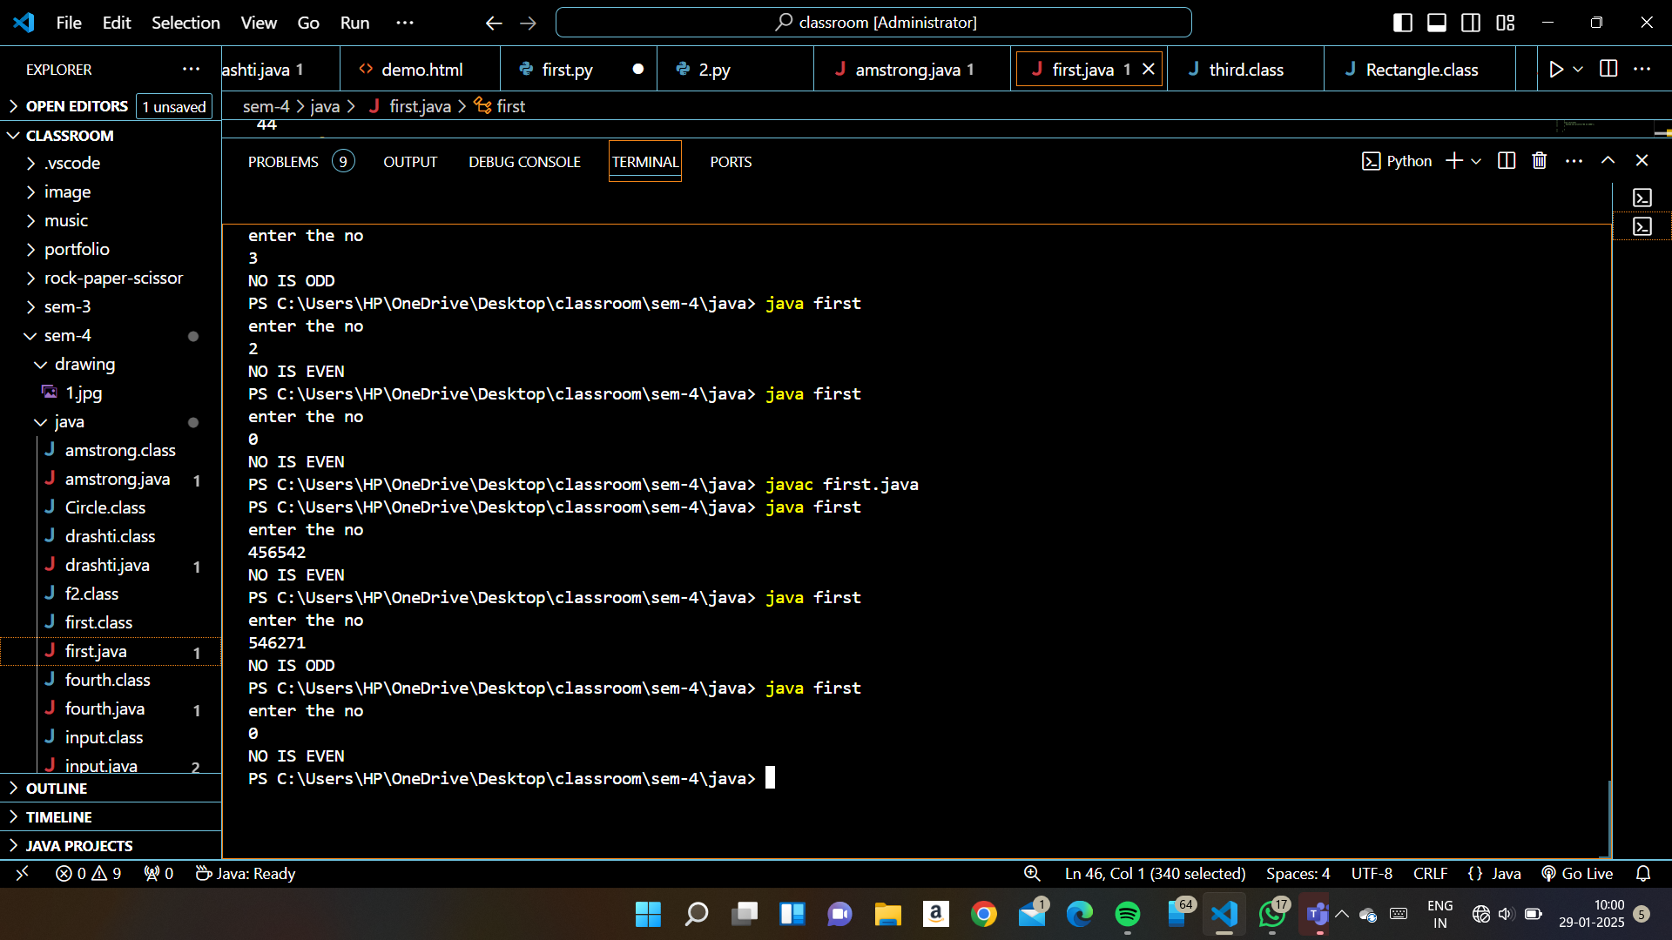

3) PROGRAM TO FIND YEAR IS LEEP YEAR OR NOT

public class first{

    public static void main(String[] args){

      Scanner sc=new Scanner(System.in);

      System.out.println("enter the no");

      int n=sc.nextInt();

      if(n%4==0 && n%100!=0 || n%400==0){

        System.out.println(+n+" YEAR IS LEEP YAER");

      }

      else{

        System.out.println( n+" YEAR IS NOT LEEP YAER IT IS SIMPLE YEAR");

      }

      }

    }

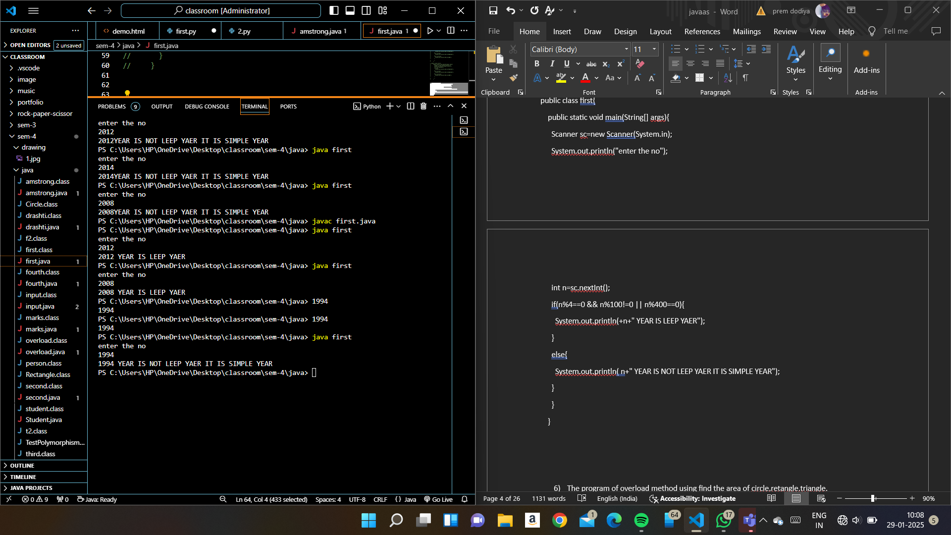

4)WRITE TO PROGRAM WHETHER NO IS DEVIDABLE BY 5 AND 11 OR NOT

public class first{

    public static void main(String[] args){

      Scanner sc=new Scanner(System.in);

      System.out.println("enter the no");

      int n=sc.nextInt();

      if(n%5==0 && n%11==0){

        System.out.println("NO IS DEVIDABLE BY 11 AND 5");

      }

      else{

        System.out.println("NO IS NOT DEVIDE BY 5 AND 11");

      }

      }

    }

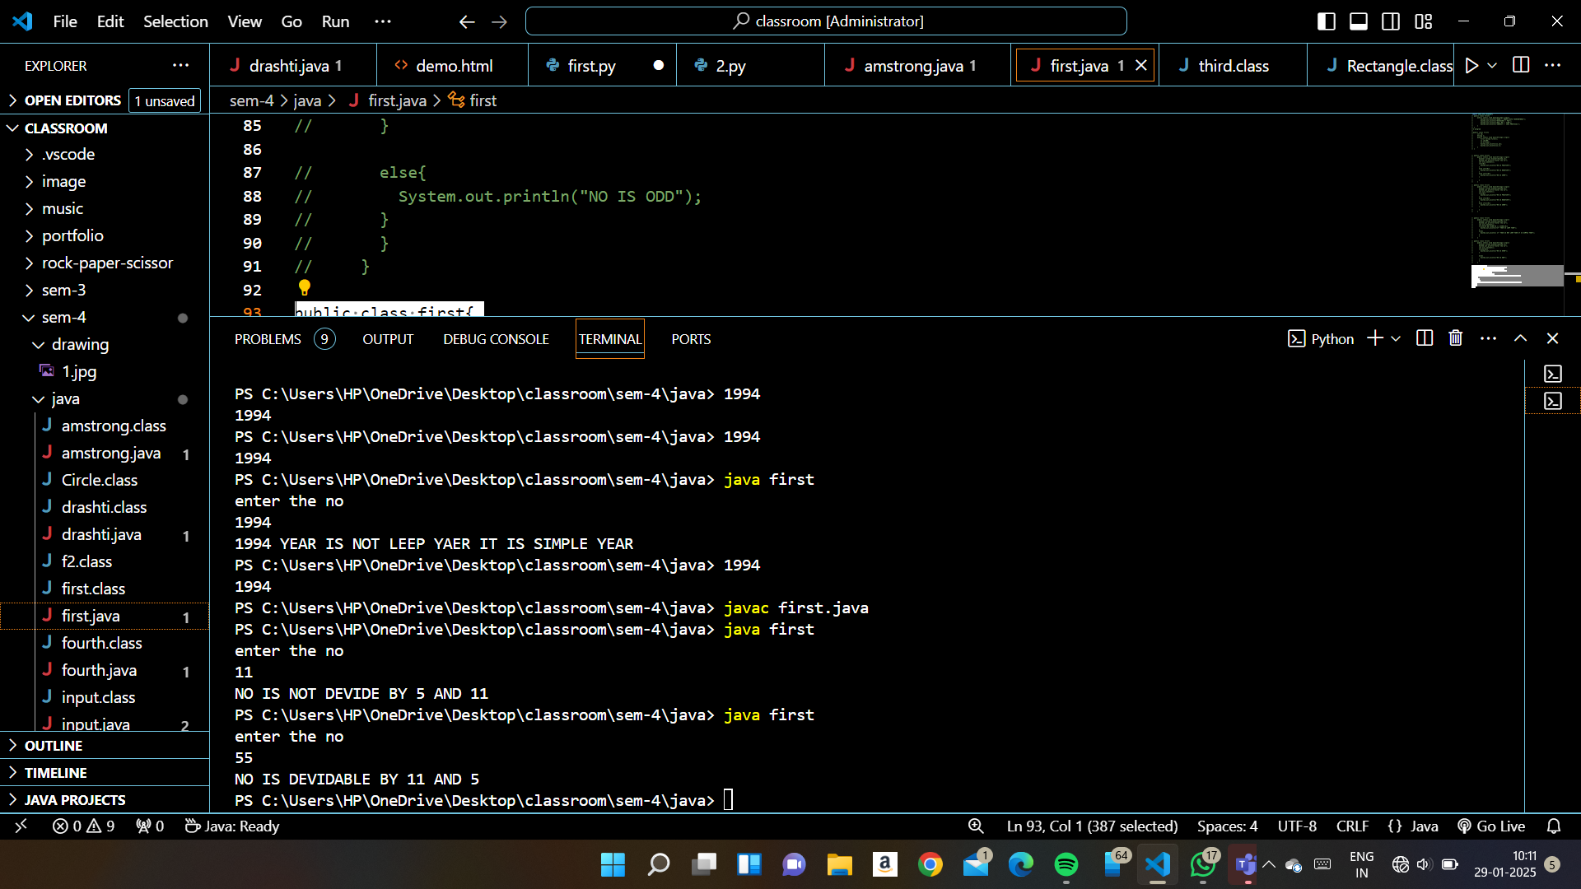

1. Calculate student percentage and print division
2. import java.util.Scanner;
3. public class marks{
4. public static void main(String[] args){
5. Scanner sc=new Scanner(System.in);
6. System.out.println("enter the no of student");
7. int no=sc.nextInt();
8. int average,sum=0;
9. int i;
10. for(i=0;i<no;i++){
11. // int marks[5]={80,85,98,33,74};
12. int SUBJ;
13. float  SUBJ_SUM =0;
14. // System.out.println("enter the marks");
15. // int marks=sc.nextInt();
16. for(int j=0;j<5;j++){
17. System.out.println("enter the subject "+j+1+"for student "+i+1+"");
18. SUBJ=sc.nextInt();
19. SUBJ_SUM += SUBJ;
20. }
21. //   int  SUBJ_SUM =0;
22. SUBJ_SUM/=5;
23. System.err.println("average of student "+i+" is "+SUBJ_SUM+" ");
24. // sum += marks;
25. if(SUBJ_SUM<100  && SUBJ_SUM>=90){
26. System.out.println("A");
27. }
28. else if(SUBJ_SUM<=89 && SUBJ_SUM>=80){
29. System.out.println("B");
30. }
31. else if(SUBJ_SUM<=79 && SUBJ_SUM>=70){
32. System.out.println("C");
33. }
34. else if(SUBJ_SUM<=69 && SUBJ_SUM>=60){
35. System.out.println("D");
36. }
37. else if(SUBJ_SUM<=59 && SUBJ_SUM>=50){
38. System.out.println("E");
39. }
40. else if(SUBJ_SUM<=49 && SUBJ_SUM>=40){
41. System.out.println("F");
42. }
43. else if(SUBJ_SUM<=39){
44. System.out.println("Fail");
45. }
46. else{
47. System.out.println("enter valid marks");
48. }
49. }
50. // System.out.println("sum is"+sum);
51. // average=sum/no;
52. // System.out.println("sum is"+average);
53. }
54. }

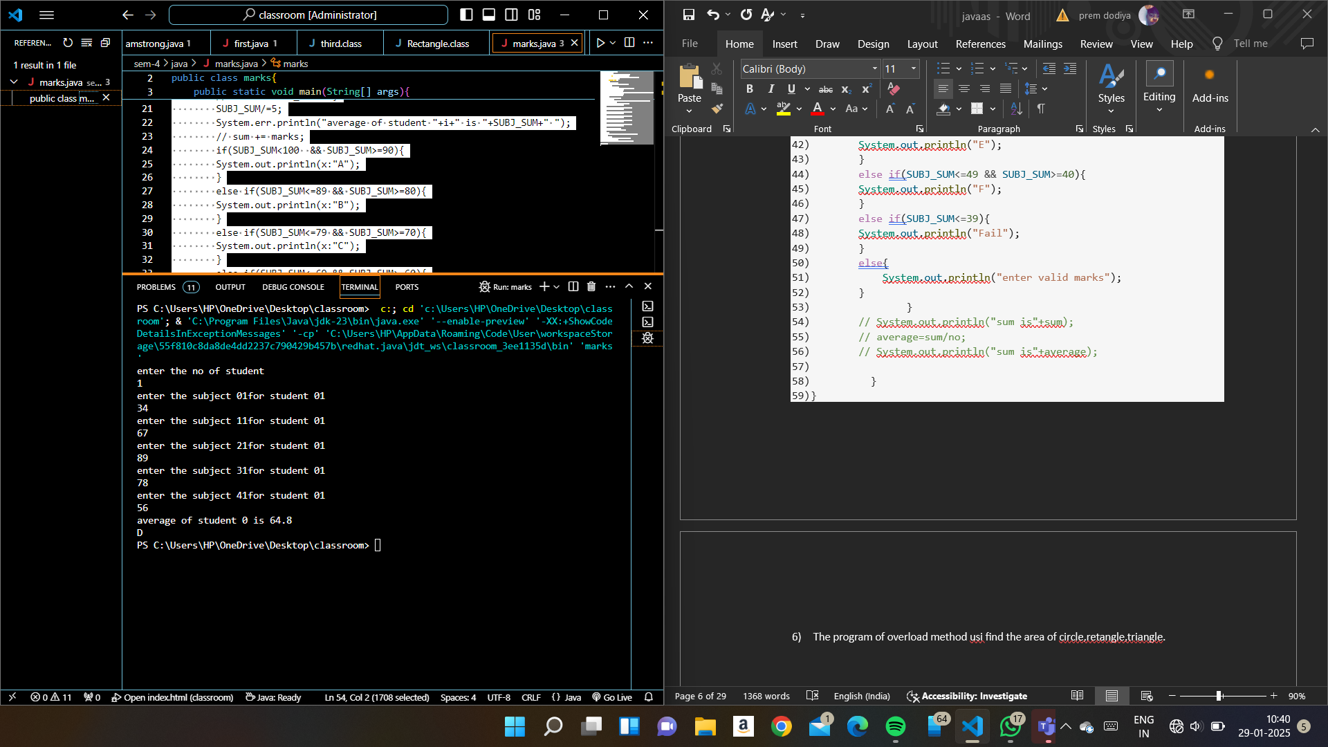

1. The program of overload method usi find the area of circle,retangle,triangle.

import java.util.Scanner;

//area of reatangale triangle and circle

public class overload{

    static double calArea(double radi){

      return Math.PI*radi*radi;

    }

    static int calArea(int height,int weight){

      return height*weight;

    }

    static double calArea(double base,double height){

      return 0.5*base*height;

    }

    public static void main(String[] args){

        System.out.println("enter 1.calculate area of circle");

        System.out.println("enter 2.calculate area of retangle");

        System.out.println("enter 3.calculate area of triangle");

        System.out.println("enter your choice");

        double areaofcir=overload.calArea(15);

        // System.out.println("area of circle is"+areaofcir);

        Scanner sc=new Scanner(System.in);

        int i=sc.nextInt();

        if(i==1){

        System.out.println("enter the radius of the circle");

        int rad=sc.nextInt();

        double rad1=overload.calArea(rad);

        System.out.println(+rad1);

        // overload.calArea(12);

        }

        else if(i==2){

        System.out.println("enter the height of retangle");

        int height=sc.nextInt();

        System.out.println("enter the weith of retangle");

        int weight=sc.nextInt();

        double retan=overload.calArea(height,weight);

        // overload.calArea(55.05,56.56);

        System.out.println(+retan);

        }

        else if(i==3){

        System.out.println("enter the base of triangle");

        double height=sc.nextDouble();

        System.out.println("enter the height of triangle");

        double weight=sc.nextDouble();

        double tria=overload.calArea(height,weight);

        System.out.println(+tria);

        // overload.calArea(3,5);

        }

        else{

            System.out.println("enter the valid choice");

        }

    }

}

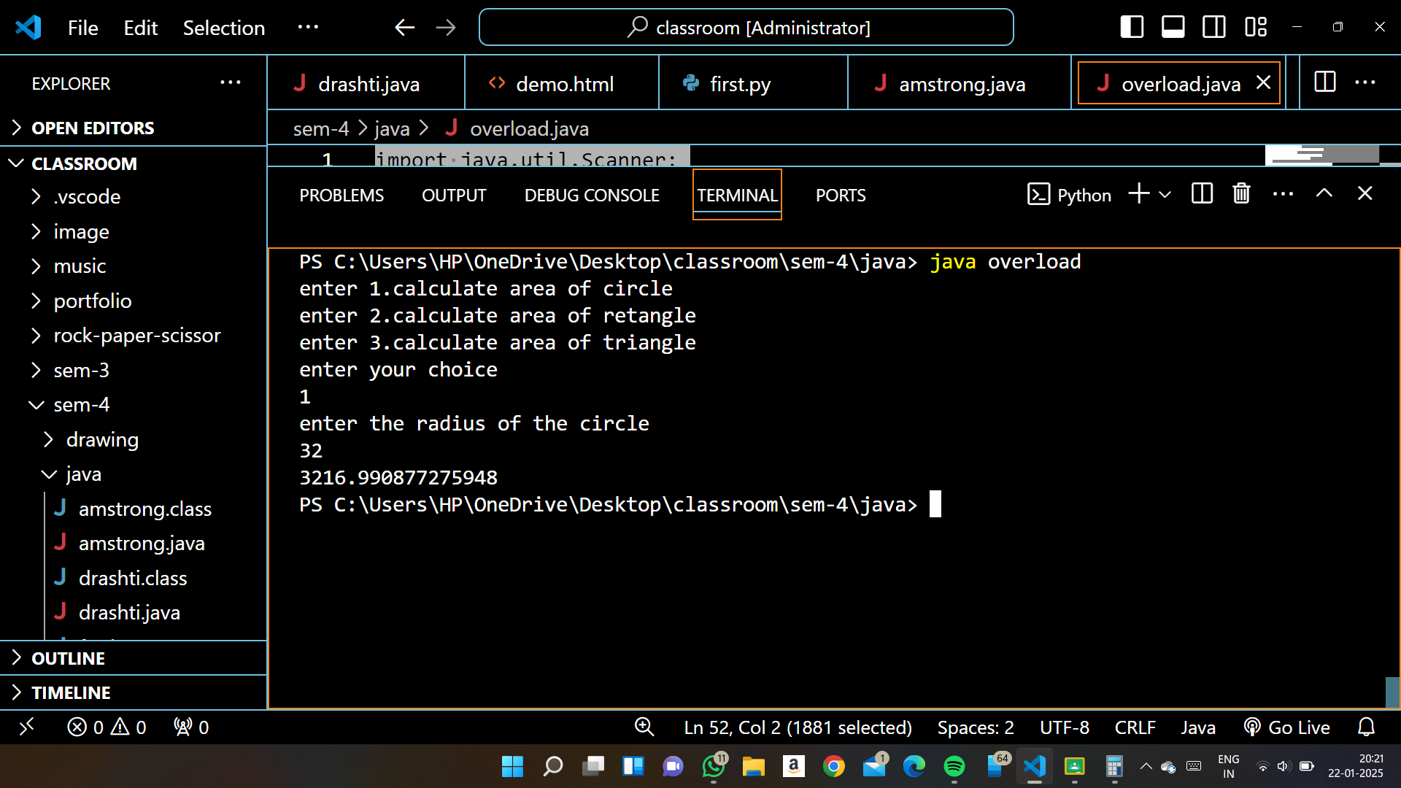

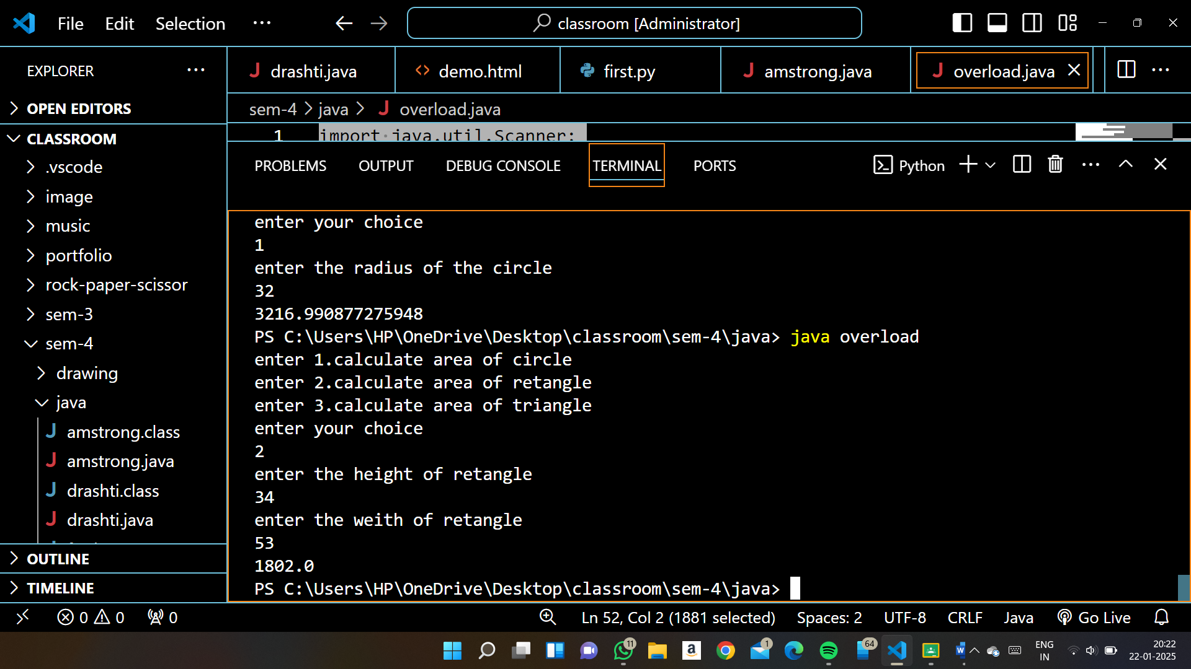

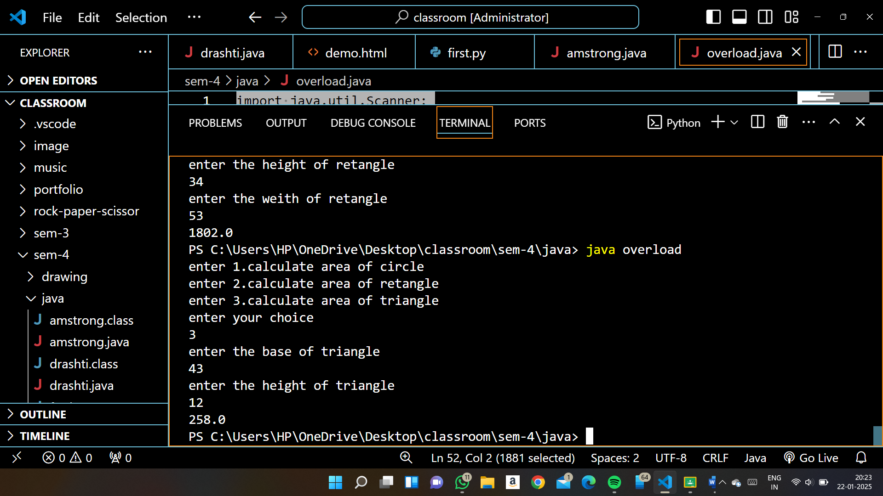

1. CHECK THE NO IS MULTIPLAY BY 5 OR NOT
2. public class first{
3. public static void main(String[] args){
4. Scanner sc=new Scanner(System.in);
5. System.out.println("enter the no");
6. int n=sc.nextInt();
7. if(n%5==0){
8. System.out.println("NO IS MULTIPLAY BY 5");
9. }
11. else{
12. System.out.println("NO IS NOT MULTIPLAY BY 5 ");
13. }
14. }
15. }

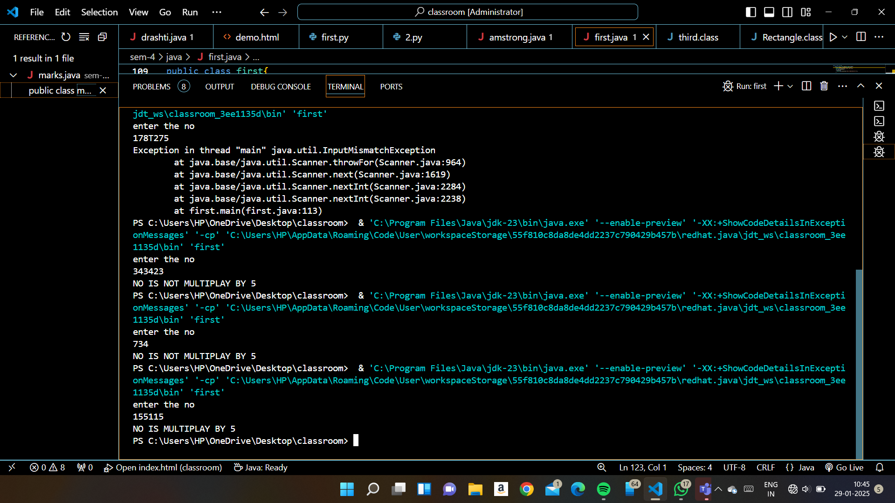

8)sum of digit

/*sum of digits */

public class drashti {

  public static void main(String[] args) {

    System.out.println("enter the no for sum of digits");

    Scanner sc=new Scanner(System.in);

    int no=sc.nextInt();

    int last;

    int sum=0;

    while (no!=0) {

    last=no%10;

    sum+=last;

    no=no/10;

    }

    System.out.println(+sum);

  }

}

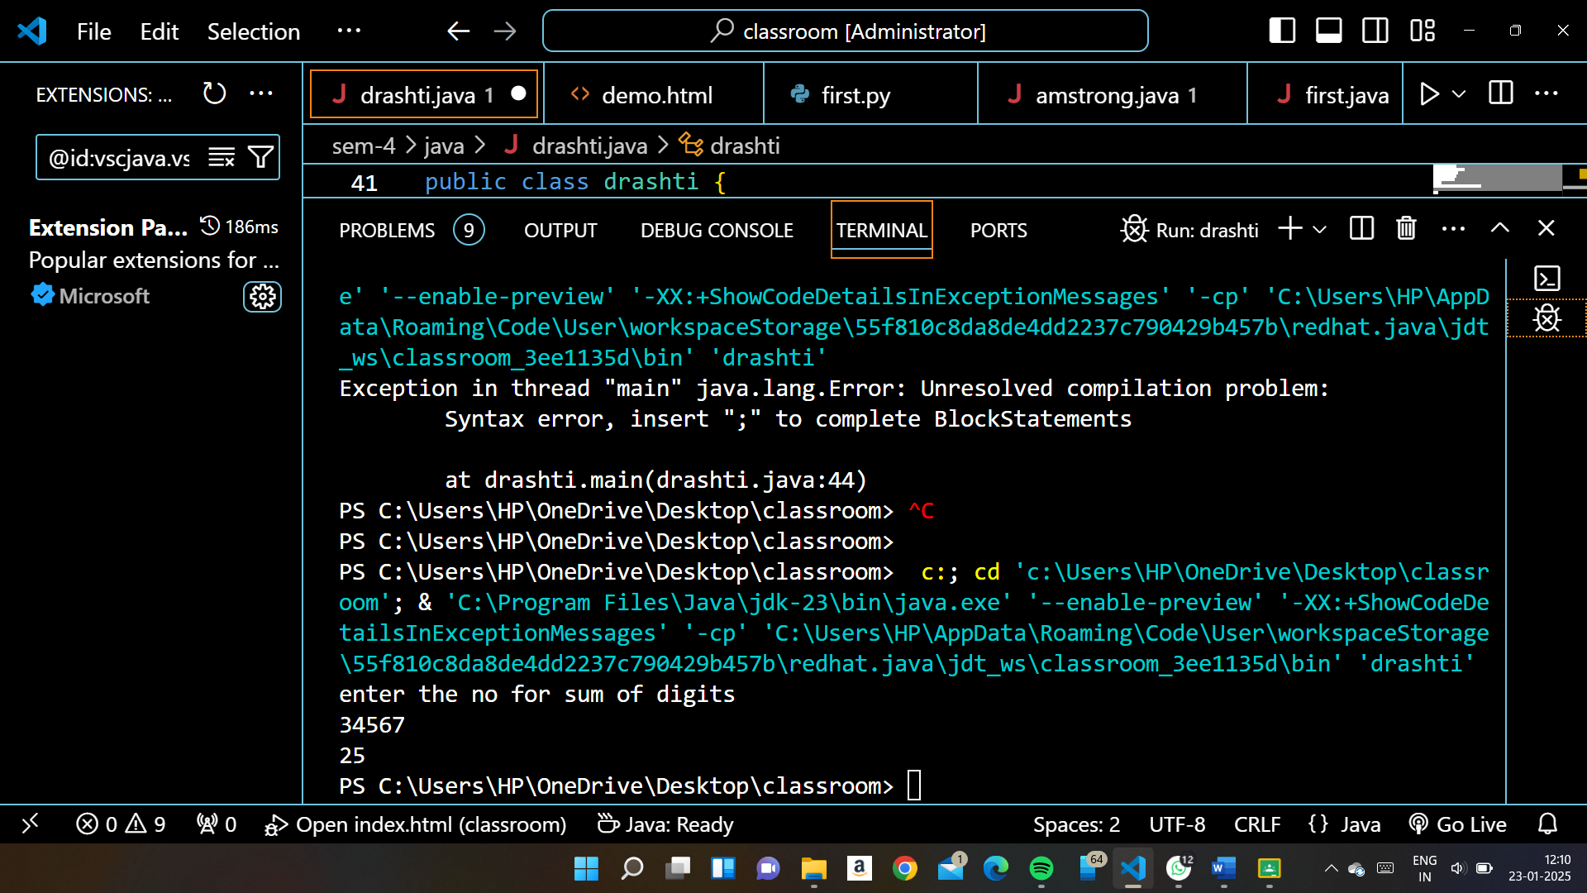

9) reverse no I java

public class drashti {

  public static void main(String[] args) {

    Scanner sc=new Scanner(System.in);

    System.out.println("enter the no to reverse string");

    int no=sc.nextInt();

    int last;

    int reverse=0;

    while (no!=0) {

    last=no%10;

    reverse=reverse*10+last;

    no=no/10;

    }

    System.out.println(+reverse);

  }

}

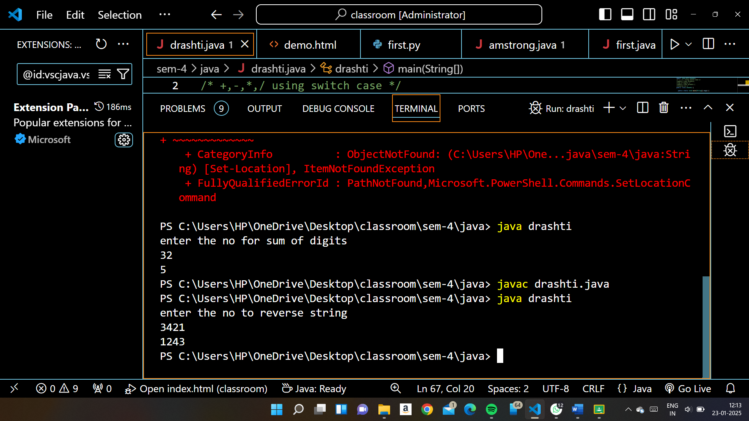

1. Arithmetic operation using switch case makecalculator

import java.util.Scanner;

/* +,-,*,/ using switch case */

public class drashti{

  public static void main(String[] args) {

    // /*calculator using switch case

     Scanner sc=new Scanner(System.in);

     double result=0;

     System.out.println("enter the value of no 1 and no2");

     double no1=sc.nextDouble();

     double no2=sc.nextDouble();

     System.out.println("enter the operation no wise +.addition,-.subtraction,*.multiplication,/.division");

     char obj=sc.next().charAt(0);

     switch (obj) {

      case '+':

        result=no1+no2;

        break;

      case '-':

        result=no1-no2;

        break;

      case '*':

        result=no1*no2;

        break;

      case '/':

      if(no2==0){

        System.out.println("in devider 0 is not allowed !ERROR");

      }

      else{

        result=no1/no2;

      }break;

      default:

      System.out.println("enter correct operation");

        break;

     }

     System.out.println(+no1+" "+obj+" "+no2+" is "+result);

// System.out.printf("%.1f %c %.1f =%.1f",no1,obj,no2,result);

  }

}

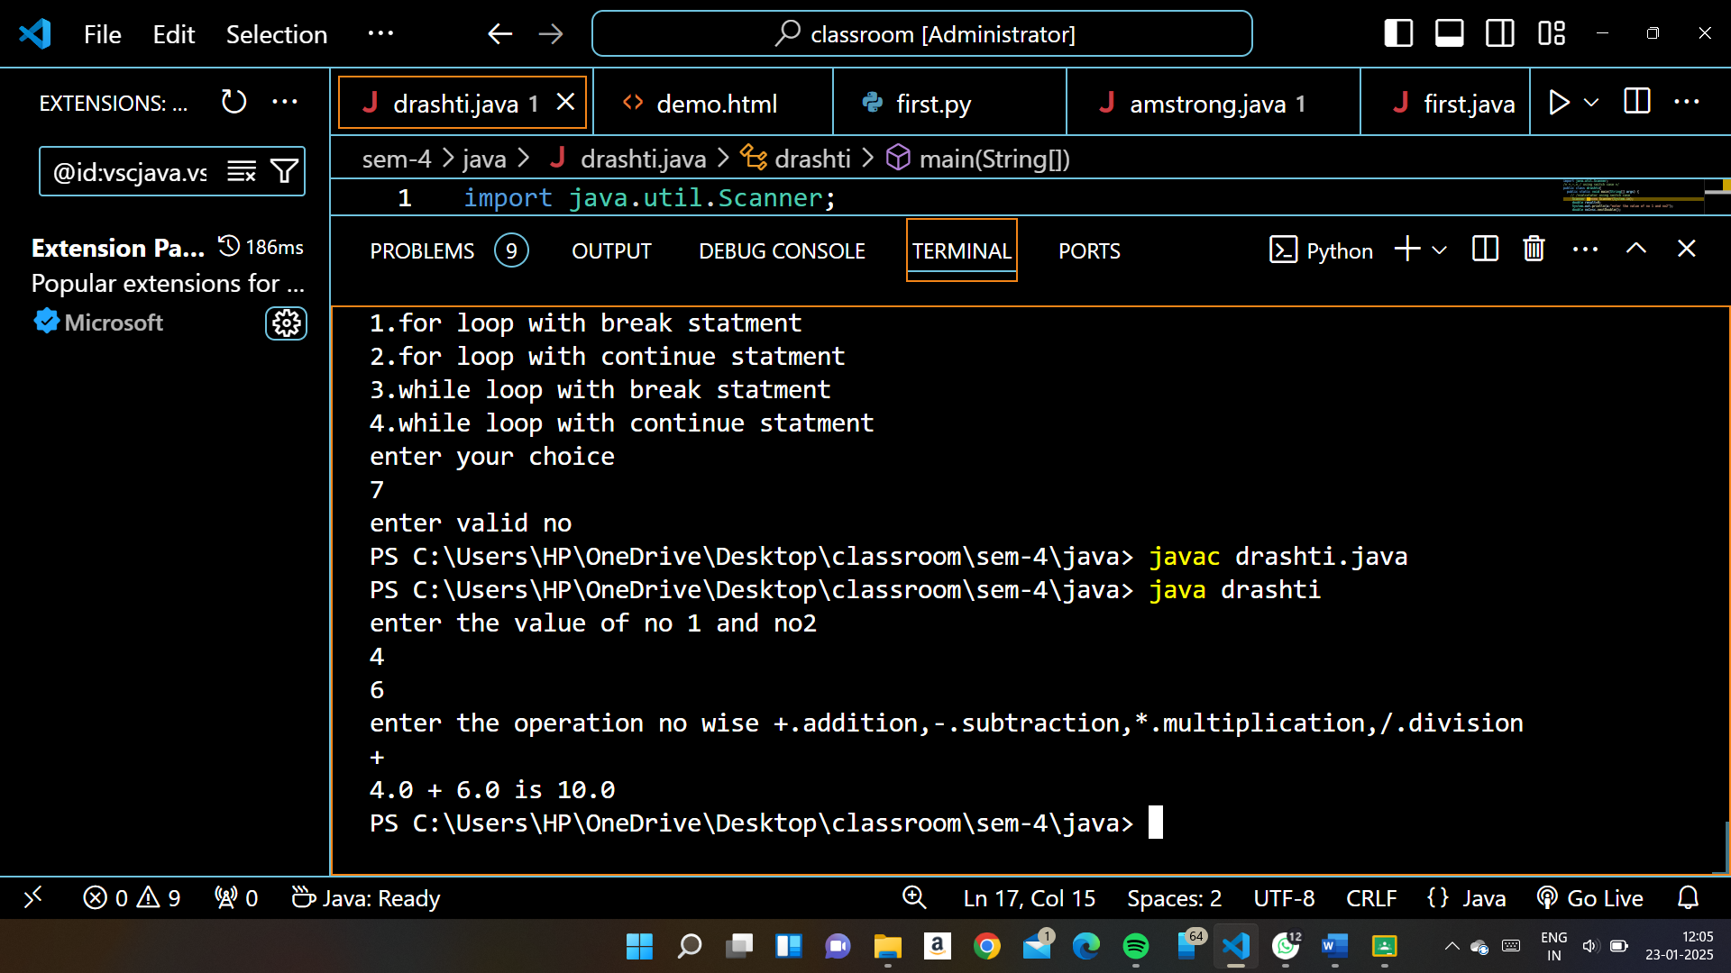

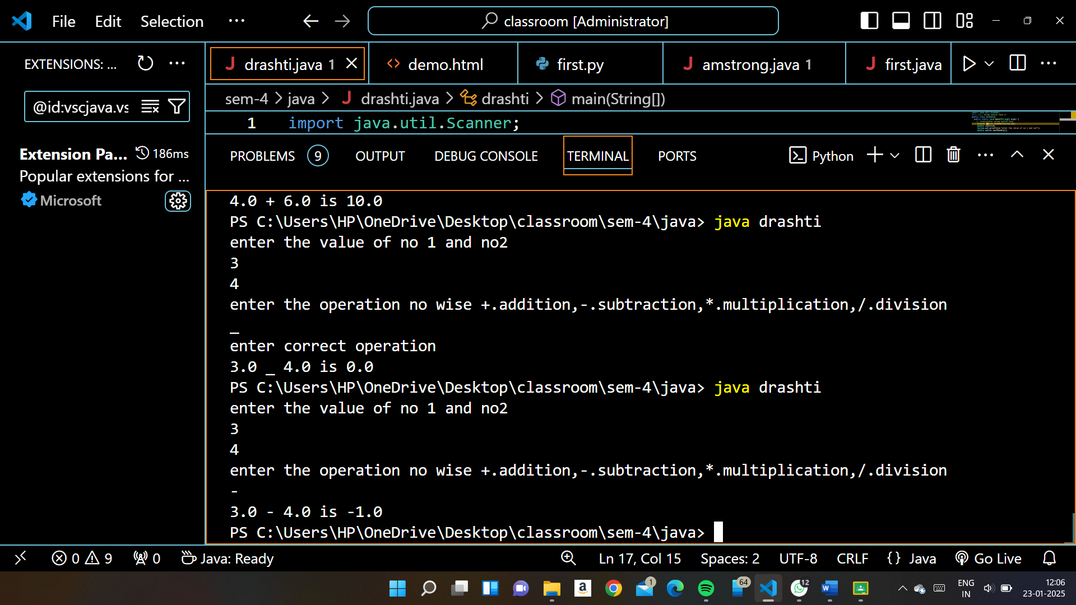

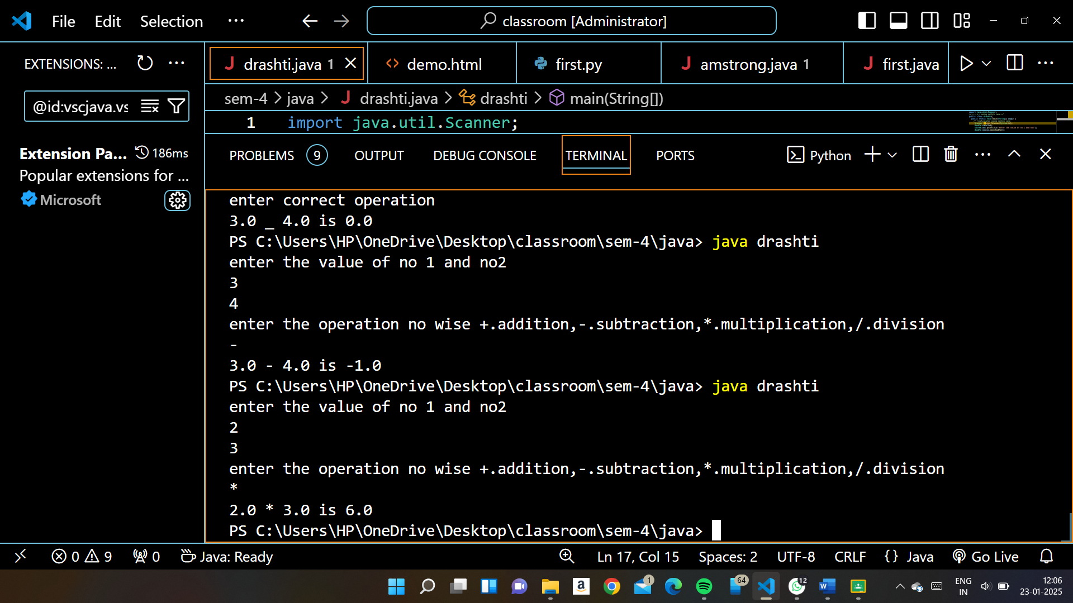

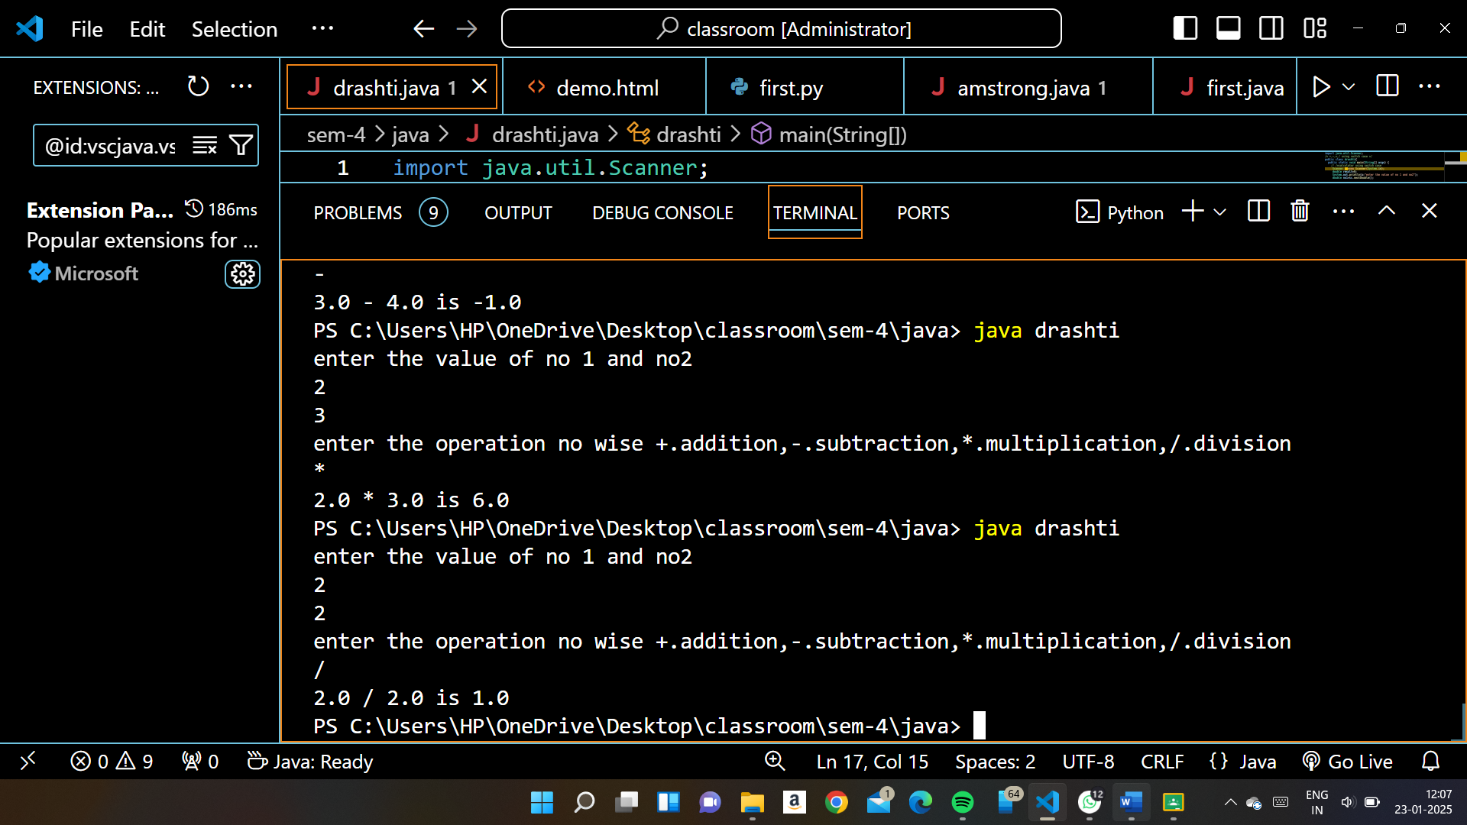

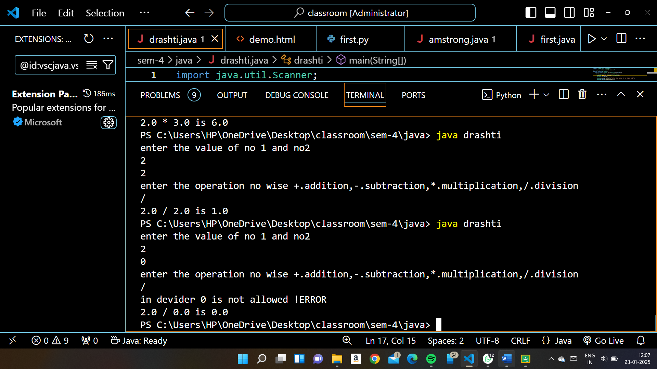

11)Factorial no:-----------------

public class amstrong{

        static void fact(int no){

        int i;

        int fact=1;

        for(i=1;i<=no;i++){

            fact=i*fact;

        }

        System.out.println("THE FACTORIAL IS "+fact);

    }

     public static void main(String[] args){

        Scanner sc=new Scanner(System.in);

        System.out.println("enter the no");

        int no=sc.nextInt();

        amstrong.fact(no);

    }

}

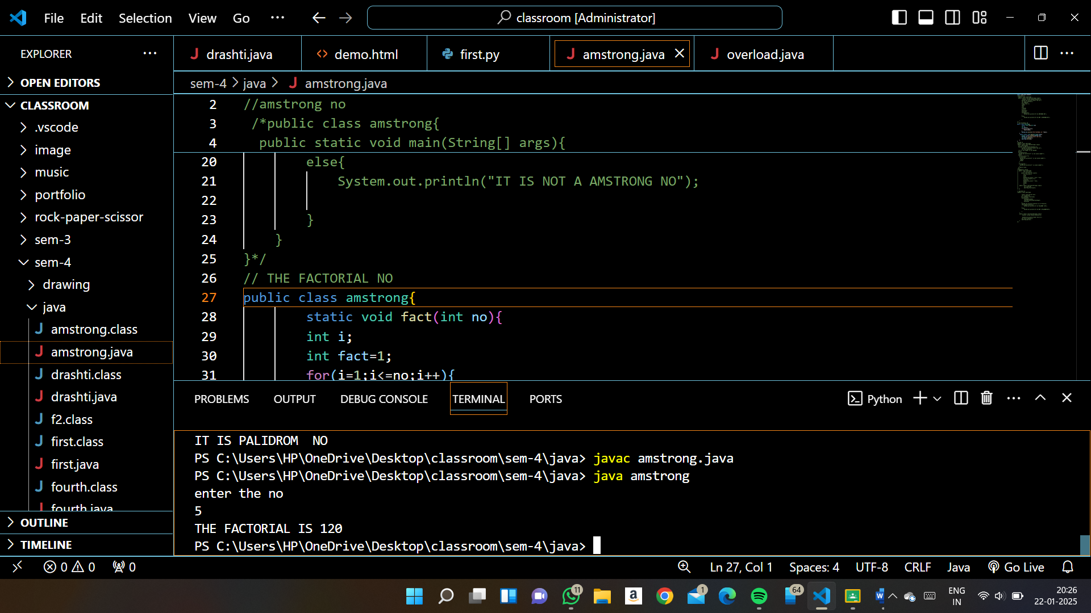

1. Fibonacci series:-----------------------------

public class amstrong{

        int n1,n2,n3,i;Ss

    static void fact(int count){

        int n1,n2,n3,i;

        n1=0;

        n2=1;

        System.out.print(" "+n1+" "+n2);

        for(i=2;i<count;i++){

        n3=n1+n2;

        System.out.print(" "+n3);

        n1=n2;

        n2=n3;

        }}

 public static void main(String[] args){

         int count=10;

         amstrong.fact(count);

}}

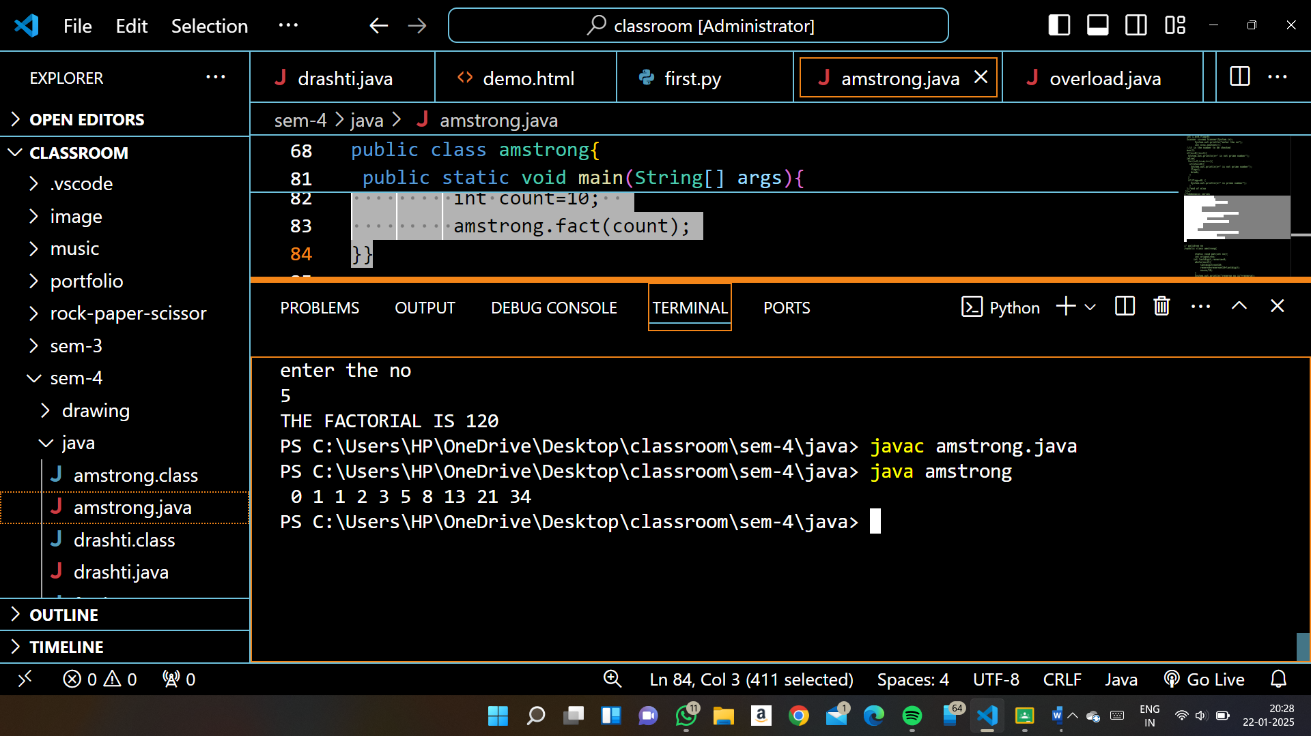

1. Palidrom no

public class amstrong{

        static void pal(int no){

        int orignal=no;

       int lastdigit,reverse=0;

        while(no>2){

            lastdigit=no%10;

            reverse=reverse*10+lastdigit;

            no=no/10;

        }

        System.out.println("reverse no is"+reverse);

        if(orignal==reverse){

            System.out.println("IT IS PALIDROM  NO");

        }

        else{

            System.out.println("IT IS NOT A PALIDROM NO");

        }

    }

    public static void main(String[] args){

         Scanner sc=new Scanner(System.in);

         System.out.println("enter the no");

        int no=sc.nextInt();

        amstrong.pal(no);

    }

}

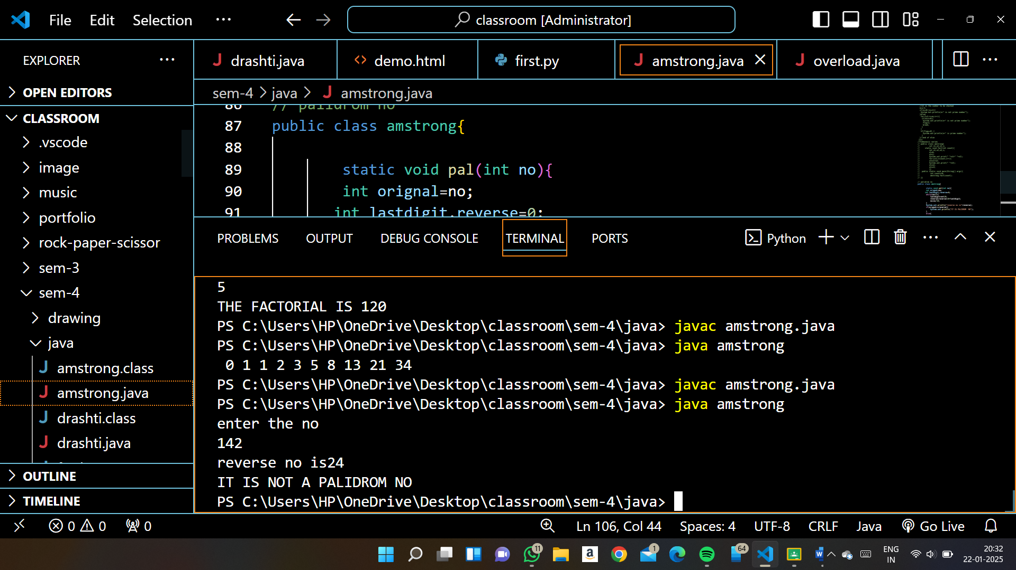

1. .Student details Instance variable Name , Rollnumber static Variable Div=B.Instance  Method DisplayName, Rollnumber. Static method dipslay Division.

  public class drashti {

    String name;

    int Rollnumber;

    static char div='B';

       public  void DisplayName(String name,int Rollnumber){

        System.out.println("name is " +name+ "  rollno is "+Rollnumber+ "  division is "+div);

       }

      //         static void Displaydiv(){

      //      System.out.println("division is "+div);

      //  }

       public static void main(String[] args) {

        drashti s1=new drashti();

        drashti s2=new drashti();

        s2.DisplayName("niya",222);

        // drashti.Displaydiv();

        s1.name="niya";

        s1.Rollnumber=111;

        s1.DisplayName("siya",111);

        // drashti.Displaydiv();

       }

    }

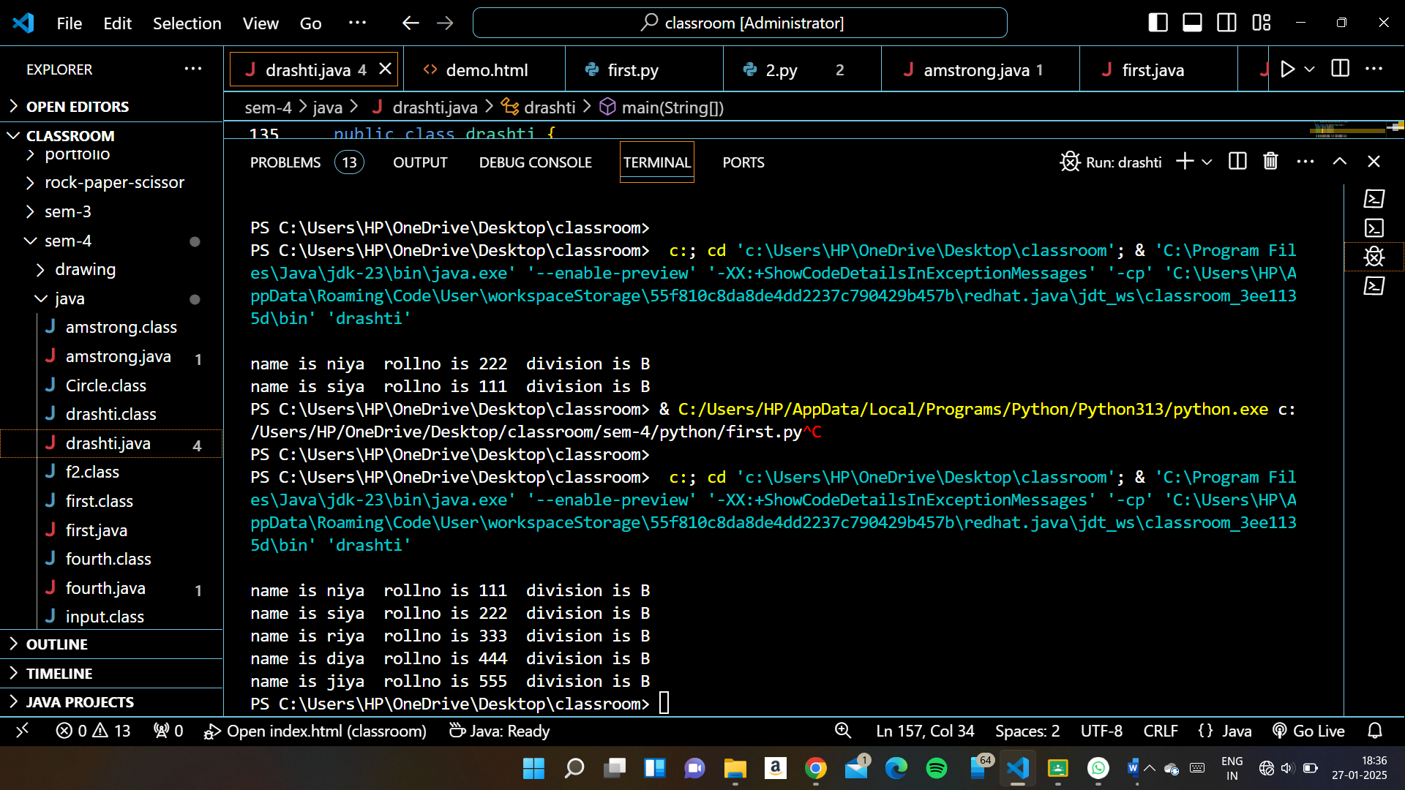

1. Employee Details Instance Variable EMP_ID,Emp_Name, Emp_designation, Emp_Salary.Static Varaible Company_Name. Intsance Method Disply Employee Details , staticMethod DisplyCompany Name

  public class drashti {

int EMP_ID;

    String Emp_Name;

    String Emp_designation;

    int Emp_Salary;

    static String Company_Name="TATA";

       public void DisplayName(int EMP_ID,String Emp_Name,String Emp_designation,int Emp_Salary){

        System.out.println("|| EMPLOYEE ID  " +EMP_ID+ " || EMPLOYEE NAME  "+Emp_Name+ " || EMPLOYEE DESIGNATION  "+Emp_designation+ " || EMPLOYEE SALARY  "+Emp_Salary+ " || COMPANY NAME  " +Company_Name);

       }

      //         static void Displaydiv(){

      //      System.out.println("division is "+div);

      //  }

       public static void main(String[] args) {

        drashti E1=new drashti();

        drashti E2=new drashti();

        drashti E3=new drashti();

        drashti E4=new drashti();

        drashti E5=new drashti();

        E1.DisplayName(1001,"Ashok kumar","Manager",45000);

        E2.DisplayName(1002,"Nayan kumar","DEP_HD",55000);

        E3.DisplayName(1003,"Mitixa patel"," H R ",75000);

        drashti.Company_Name="BIRLA";

        E4.DisplayName(1004,"Nitin kumar","Sales_man",35000);

        E5.DisplayName(1005,"priti kumari","Sales-Rep", 30000);

        // drashti.Displaydiv();

       }

    }

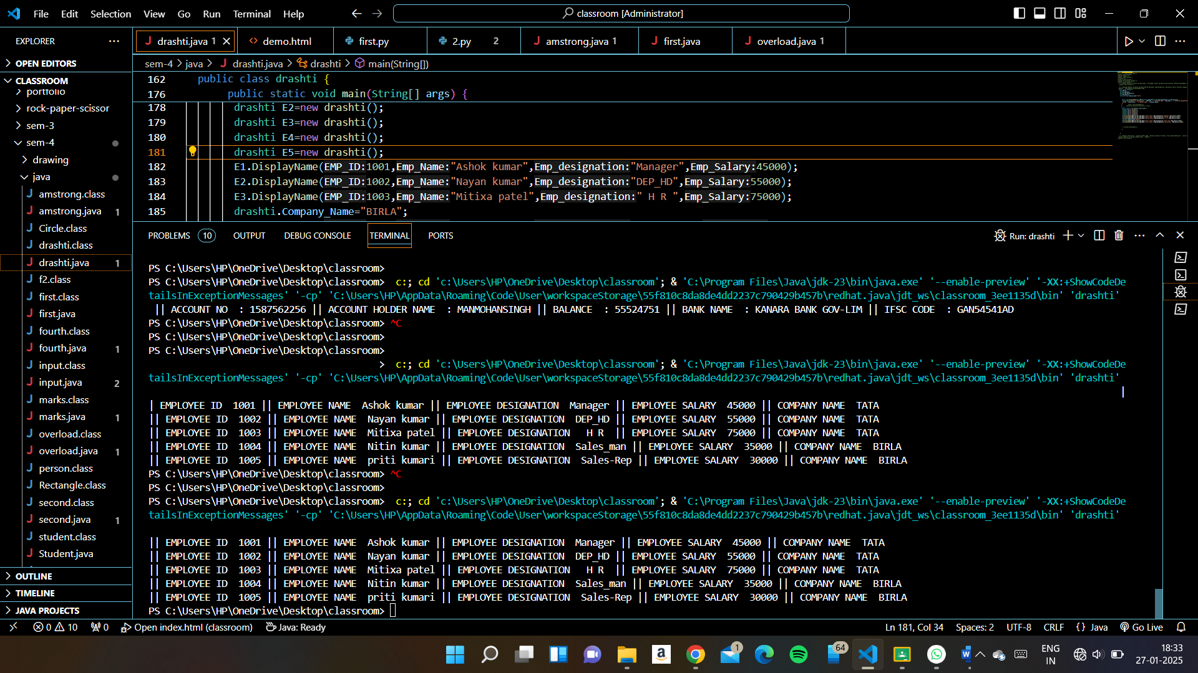

1. Default Constructor : Account holder name , Balance Instance Variable, Class name BankAccount , constructor name BankAccount , Instance Method Display Details of Account Holder name ,  Balance .

public class drashti{

  int AC_NO;

  String AC_NAME;

  int BAL;

  static String BANK_NAME="KANARA BANK GOV-LIM";

   static String IFSC_CODE="GAN54541AD";

   // MAKE PERAMETER WISE CONSTRUCTOR

  //  drashti(int i,String n,int s){

  //    AC_NO=i;

  //    AC_NAME=n;

  //    BAL=s;

  //  }

// WITHOUT PERAMETER CONSTRUCTOR

  drashti(){

    AC_NO=1587562256;

    AC_NAME="MANMOHANSINGH";

    BAL=55524751;

  }

     public void DisplayName(){

      System.out.println(" || ACCOUNT NO  : "+AC_NO+" || ACCOUNT HOLDER NAME  : "+AC_NAME+ " || BALANCE  : "+BAL+ " || BANK NAME  : "+BANK_NAME+ " || IFSC CODE  : "+IFSC_CODE);

     }

    //         static void Displaydiv(){

    //      System.out.println("division is "+div);

    //  }

     public static void main(String[] args) {

      // drashti A1 = new drashti(54545544,"karan arayan",5545521);

      // A1.DisplayName();

      // drashti A2=new drashti(54545545,"neha swamii",55555);

      // A2.DisplayName();

      // drashti A3=new drashti(54545548,"siya ramani",5452145);

      // A3.DisplayName();

      // drashti A4=new drashti(54545544,"meshva dave",1237452);

      // A4.DisplayName();

      // drashti A5=new drashti(54545524,"ruchee mangal",4521731);

      // A5.DisplayName();

// WITHOUT PERAMETER CONSTRUCTOR

drashti A6 = new drashti();

A6.DisplayName();

      // drashti.Displaydiv();

     }

  }

